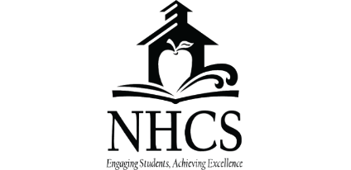
Family Education Rights and Privacy Act
Opt-Out Form
Parents and guardians have the right to opt-out of sharing directory information. More information about you FERPA rights may be viewed at this link: https://www.nhcs.net/general-forms
Please complete and return this form if you wish to maintain control of the release of directory information pertaining to your child.
- Schools use directory information to publish items such as yearbooks, honor roll, and graduation announcements. This also includes information about opportunities for scholarship programs and colleges to be sent to you.
- Directory information may include student’s name, address, telephone number, date and place of birth, participation in officially recognized activities and sports. A school may disclose directory information to third parties for non-commercial use only.
- Schools will never sell information to third parties for commercial purposes. Directory information will only be used for official purposes and to college and universities if you so choose.

Please indicate below if you would like to opt-out of any of the following. By not returning this form you are consenting to the statements below.

- Do you grant permission to allow directory information to be shared for non-commercial purposes? (yearbook, honor roll, etc.)
- Do you grant permission for your student’s contact information be provided to the US Military for the sole purpose of informing students of potential career opportunities?
- Do you grant permission to share information with NC public and private colleges?
(This would include the state-administered nationally-recognized college readiness assessment, currently the ACT, that students take the Junior year of high school).

Student Name __________________________ School_____________________________________

Parent Signature ________________________ Date_______________________________________

